GIS MISSION

Kilifi County, Magarini constituency, Marafa ward, GIS location.

Mission conducted on 12th March 2022 to 31ST March 2022.

This special report was written by brother Daniel in conjunction with the views and reports given by fellow brethren in the mission field.

In fulfillment of our Lord and Saviour Jesus Christ, that “go ye therefore, and teach all nations, baptizing them in the name of the Father, and of the Son, and of the Holy Ghost. Teaching them to observe all things whatsoever I have commanded you;” we took our minds to the mission. Matthew 28:18-20.” Let your light so shine before men that they may see your good works and glorify your Father in heaven.” Matthew 5:16. We purposed in our hearts to share the gospel message sown in our hearts to the people in GIS.

This mission was conducted by Brother Nyasani, Sister Esther, Brother Isaac, Brother Tom, Brother Robert and Brother Daniel. All glory and honor to God, the Father and Jesus Christ our Lord and Saviour.
GIS MISSION REPORT
The mission started on the 12th March at GIS. At first, we were only three of us, Brother Wycliffe, Sister Esther and Brother Daniel. We rented in a local house. The permit for open air meetings by the local authorities dated from 12th to 31st March, given by the chief. GIS area had General Conference SDA church, Kazaeni District SDA church. It was a district church in the locality. They had recently done an open-air crusade in the area about a month before, mainly on family life and health. The church had a large following in the area. Brother Daniel was doing Bible Study and Sermon. Sister Esther was preaching about Health Message. Brother Wycliffe was doing Prophecy. 12th March was a sabbath when we started our gospel campaign. Commencing our work, the people were surprised, especially about who we are, mostly the (General Conference) GC SDA, who mostly were agitated of because of the work we were doing. They would approach people at the Centre where we were doing the crusade warning them against coming to listen. This is really disheartening way to deal with those differing with your opinion. The best policy in dealing with error is neither to close your ears nor of those who look up to you but it is to ground them in truth. Using precious time moving from person to person scaring them from meetings turns religion to politicking. This was not only done by our SDA brethren but also by other churches who did warn their faithfuls from coming to the meeting. Regardless of this, people were very curious to hear and know what we were sharing and that made the clergy furious so they were forced to listen from distant spots. We got to know this from the locals who gathered courage to come and fellowship with us. It reminded us of the experience of Christ “Notwithstanding their efforts to counteract His work, Christ was gaining, even in Jerusalem, an influence over the people greater than their own. Multitudes who were not interested in the harangues of the rabbis were attracted by His teaching.” {DA 204.4}
The local pastor of the GC SDA visited us on 14th March Tuesday, together with a local elder of the church. They wanted to know about who we are; we did the best to explain that we are self-support Adventist missionaries but this didn’t make sense because they felt we needed their permission before coming to preach. We plea with our fellow Adventist brethren to restudy the topic of organization and its divine purpose. Organization should not be used to create mechanical protocol to hinder the work. One of the topics presented during bibles study was Godhead, this controversial topic needs much prayers for the trinity is dearly cherished as truth by all Christian bodies, so when it is taught otherwise it is really startling. It wasn’t different in this mission, however many saw sense from the harmony of scriptures shared, some were happy- Muslims were excited to hear Christians hold up the truth about one God. Perhaps we need to stick with the bible in order to make it easier to win our Muslim brothers. We shared different literature materials. We gifted few souls’ bibles, health leaflets, prophesy pamphlets, true sabbath day books, health, knowledge of God’s character and Godhead.
We started our door-to-door campaigns 20th March, Sunday after other brethren joining us from Nairobi. We would do door to door campaigns in the morning hours and the open-air meetings during the afternoon hours. It did keep us on motion but we thank God for this and we recommend visitation during your mission activities. There people you can never reach if you wait souls to come to listen to your preaching. Two of the souls baptized were as a result of personal contact with them via medical missionary and personal bible studies. This being married men; we are hopeful that we will soon have their families join us. We also have a Sunday church to follow up with who had invited us to share during their service, we hope that this continue until their eyes are open to the present truths of this time. You can tell that ground work is a beautiful and rich experience as we brought Christ in the individual houses.
The two last sabbaths we had in attendance visitors who later were converted to the truth. The open-air meeting ended in 31st March Thursday. WE REMAIN FOREVER GRATEFUL FOR EVERY FAMILY and INDIVIDUALS who God used to sustain the campaign. Please on behalf of the entire team of missionaries and souls blessed by this effort receive our Christian greetings and thanks to your families. During the last sabbath, 4 people decided to join our movement and some got baptized. They were baptized at the ocean. There is more to be expected after follow up so pray with those left behind to do follow up. One of our brother who had not been baptized, Brother Robert, gave himself to the waters of baptism. The ordinance was conducted by brother Wycliffe Nyasani. Brother Wycliffe and Sister Esther, will be left at the mission field to do the follow ups and visitations to the converted brethren and enforcing truths to them. If you would wish to support the follow up be in touch with us to get particulars that may need your support.

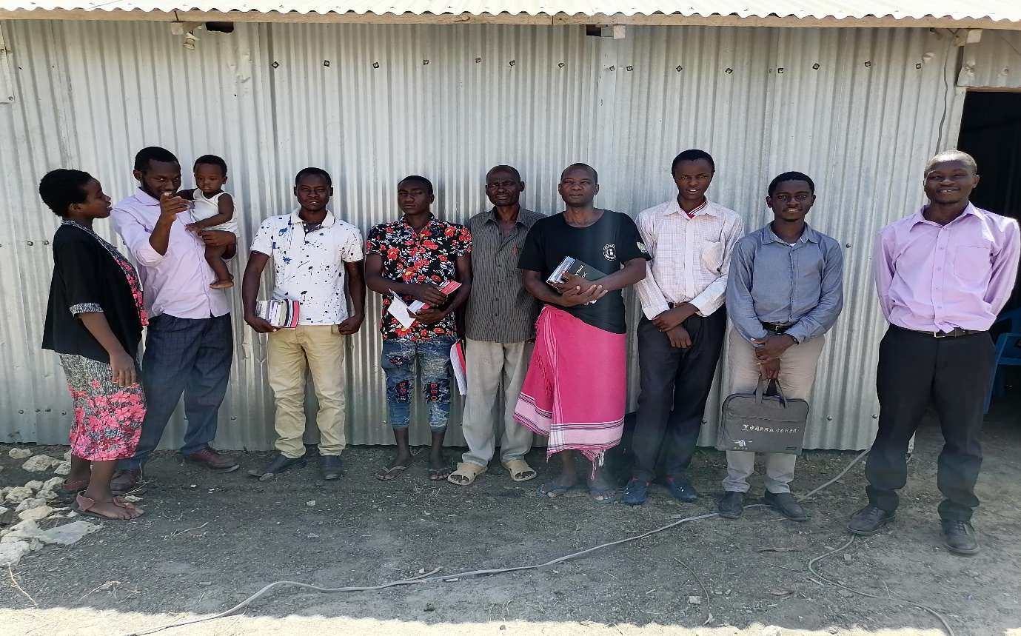
From left to right: Sister Esther, Brother Wycliffe, Young Hananiah, Brother Eric, Masha, Michael, Katana, Robert, Tom, Isaac.
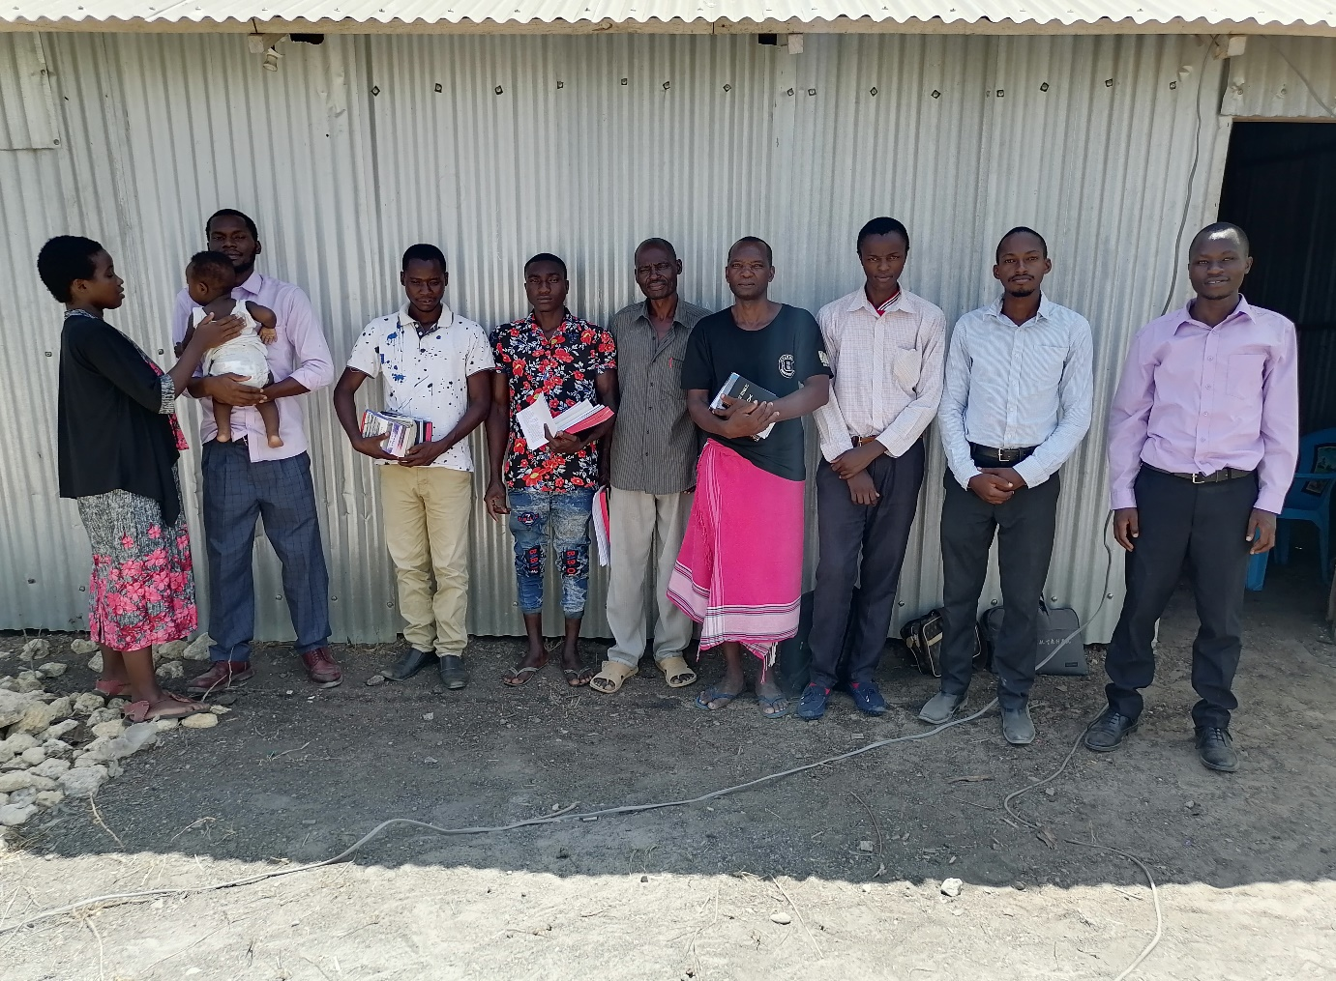
From left to right: Sister Esther, Brother Wycliffe, Young Hananiah, Brother Eric, Masha, Michael, Katana, Robert, Daniel, Isaac.
PRAYER ITEMS
Pray for Michael, his daughter has suffered from paraplegia for 5 yrs. now.
Pray for Katana and bro Erick, both family prayer requests.
Pray for those we are to meet during follow up.

Contacts:
nyasaniwycliffe@gmail.com
0703894560/0710582918

